Laboratory 02: RF Propagation & Network Analysis
ITAI-4370 — AI 5/6G Communications & ORAN Networks
Instructor: Tawanda Chiyangwa

Activity 1: Network Protocol Analysis with Wireshark

Objective
Use Wireshark to capture live network traffic and examine how packets are structured, what protocols are used, and how devices communicate over a TCP/IP network.

Steps Performed
- Downloaded and installed Wireshark from wireshark.org
- Opened Wireshark and selected the active Wi-Fi network interface
- Started a live packet capture and browsed several websites
- Stopped the capture after approximately one minute
- Applied display filters to isolate specific traffic types (ip, tcp, http)
- Analyzed packet headers including source/destination IPs, protocols, and port numbers
- Saved the capture as evidence — screenshot included below

Capture Evidence
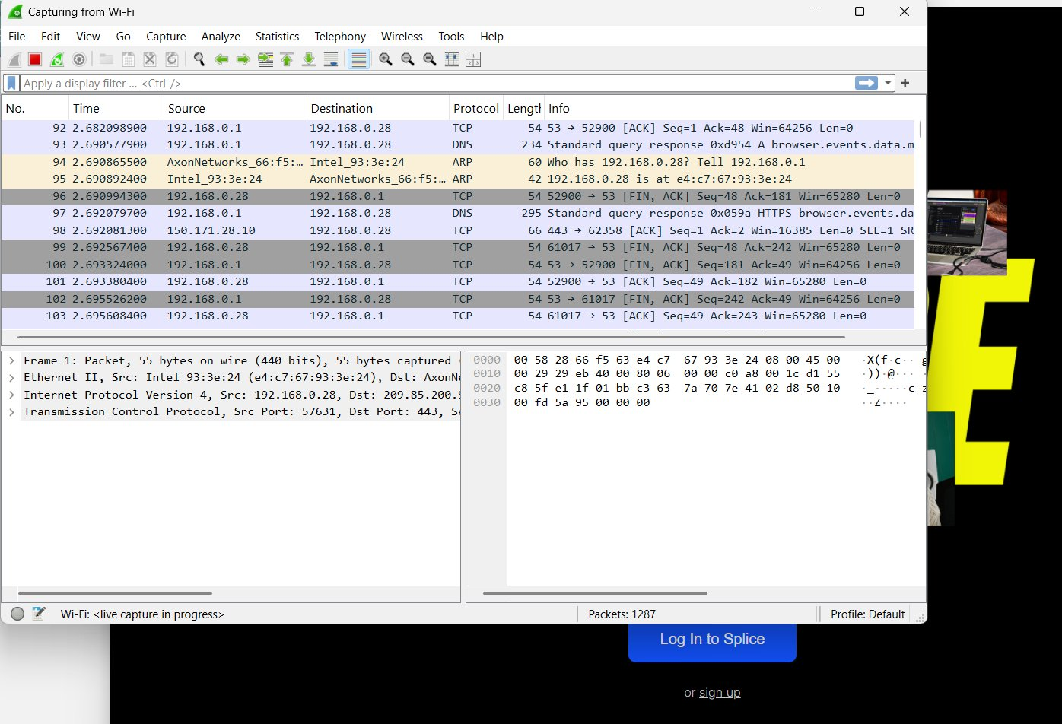
Figure 1: Live Wireshark capture on Wi-Fi interface (1,287 packets captured)

Observations
The capture shows a mix of TCP, DNS, and ARP packets occurring within milliseconds of each other. The local machine at 192.168.0.28 communicates with the router at 192.168.0.1 and an external server at 150.171.28.10.
- TCP: Connection management packets with FIN/ACK flags indicate sessions being opened and closed.
- DNS: The computer is resolving domain names to IP addresses before connecting to websites.
- ARP: Local devices identifying each other's MAC addresses on the network.
- Port 443 (HTTPS): All web traffic used HTTPS rather than plain HTTP, which is standard for modern websites.
- Packet detail panel: Confirms Ethernet II framing, IPv4 addressing, and TCP transport, showing all layers of the TCP/IP stack.

Activity 2: RF Propagation Modeling with Python

Objective
Use Python to simulate how wireless signals lose strength as they travel through open air by applying the Free-Space Path Loss (FSPL) formula to a 2.4 GHz WiFi signal across varying distances.

Background
When a radio wave moves away from a transmitter, its energy spreads out over a larger area, meaning less of it reaches the receiver. The amount of loss depends on distance and frequency. The formula used:
FSPL (dB) = 20 × log₁₀(d) + 20 × log₁₀(f) + 32.44
Where d = distance in km and f = frequency in MHz. Higher dB means more signal loss.

Python Code
import numpy as np
import matplotlib.pyplot as plt

# Parameters
frequency = 2400 # MHz (2.4 GHz WiFi)
distances = np.linspace(0.1, 20, 100) # km

# FSPL calculation
fspl = 20*np.log10(distances) + 20*np.log10(frequency) + 32.44

# Plot
plt.figure(figsize=(8, 5))
plt.plot(distances, fspl, label="FSPL at 2.4 GHz")
plt.xlabel("Distance (km)")
plt.ylabel("Path Loss (dB)")
plt.title("Free-Space Path Loss vs Distance")
plt.grid(True)
plt.legend()
plt.show()

Program Output
RF Propagation Modeling with Python
Frequency: 2400 MHz

Distance (km) FSPL (dB)
---------------------------
0.10 80.04
2.11 106.53
4.12 112.34
6.13 115.79
8.14 118.26
10.15 120.17
12.16 121.74
14.17 123.07
16.18 124.22
18.19 125.24

Output Graph
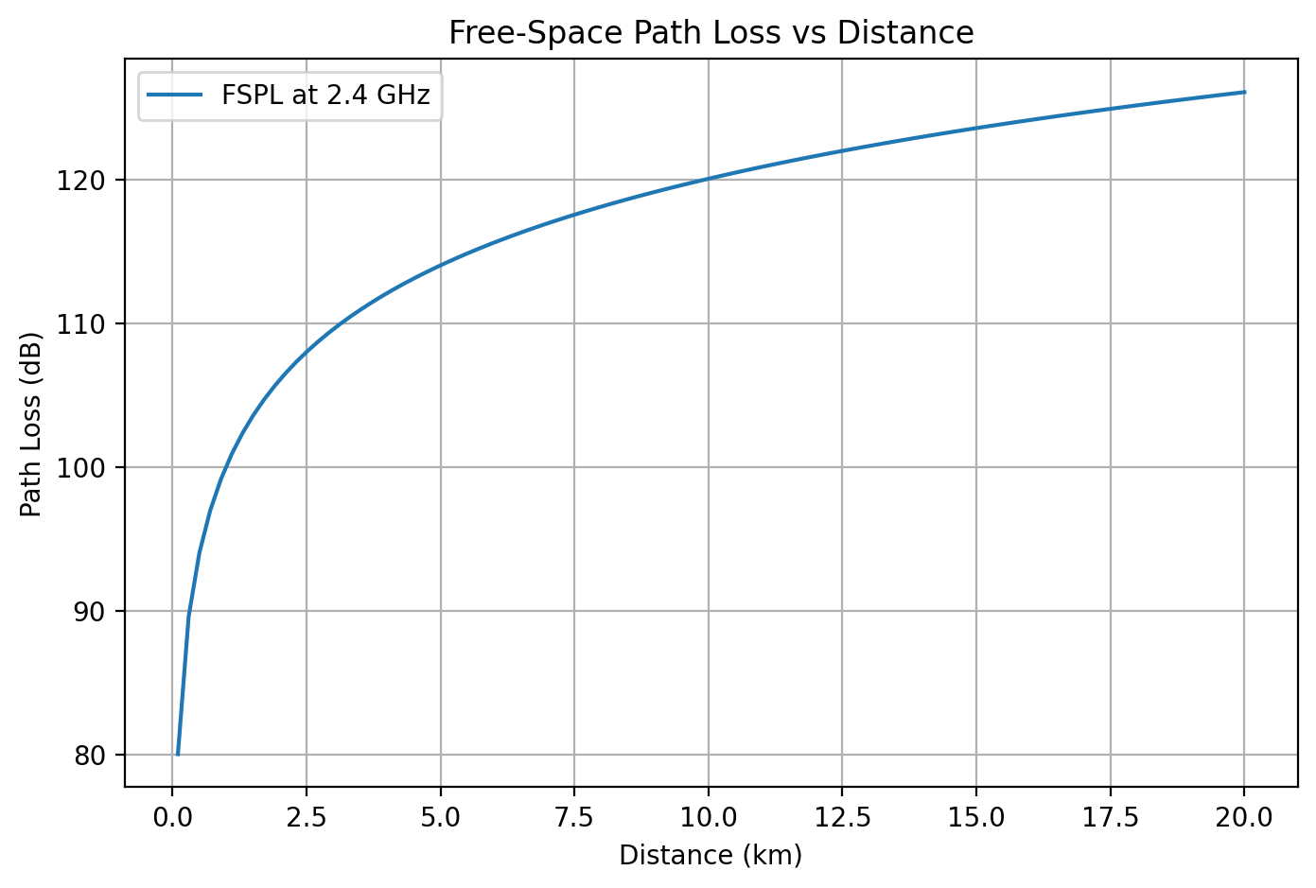
Figure 2: Free-Space Path Loss vs Distance at 2.4 GHz

Analysis
Even at a short distance of 0.1 km the signal already experiences about 80 dB of loss. As distance grows, the loss keeps climbing but the rate slows down — that is the logarithmic scale at work. By 10 km the signal has lost roughly 120 dB, and at 20 km it is around 126 dB.
This explains why standard 2.4 GHz WiFi is only practical within a few hundred meters under real conditions. The 10-20 km range shown in the simulation would require specialized antenna hardware to overcome that level of path loss.

Conclusion
Both activities demonstrated core telecommunications concepts in a hands-on way. The Wireshark capture showed how real network packets flow across a TCP/IP network, including DNS lookups, TCP connections, and encrypted HTTPS traffic. The Python simulation used the FSPL formula to quantify how 2.4 GHz signals degrade over distance. Together these exercises connect theory to real-world wireless and networking behavior.

